Spatial Population Model

1.0 Background 2
2.0 The Solution 2
3.0 General Concepts 3
3.1 The World 3
3.2 Time 3
3.3 Processes 3
3.4 Estimation 3
3.5 Validation 3
3.6 Configuration 4
3.7 Runtime-Relationships 4
4.0 Technical Information 5
5.0 Compiling SPM 5
6.0 The Object Orientated Model 6
6.1 The Base Classes 6
6.2 The Manager Pattern 6
6.3 The Process/Data Classes 7
6.4 The World 7
6.5 Parent-Child Hierarchy Diagrams 7
6.5.1 Base Classes 7
6.5.2 Configuration Loaders 8
6.5.3 Directed Processes 8
6.5.4 Estimates 8
6.5.5 Layers 9
6.5.6 Minimizers 9
6.5.7 Observations 10
6.5.8 Print States 10
6.5.9 Priors 11
6.5.10 Processes 11
6.5.11 Selectivities 12
7.0 The Modelling Process 13
7.1 Initialisation Phase 13
7.2 Modelling Phase 13
8.0 The Print States 14
9.0 Estimable Values 14
10.0 Configuration Files 15
11.0 Estimate Value Input & Output 15
12.0 Minimisation 16
13.0 Profiling 16
14.0 MCMC 16
15.0 Parameter Parser 17
16.0 Macros (for numeric comparison) 17
17.0 Unit Testing 18
18.0 Translations and Configuration Files 18

1.0 Background

There was a need to model the population of a fish (Antarctic Code) across a spatial structure. NIWA currently has a tool called CASAL that is able to model the abundance of a fish up-to about 3 spatial locations. Something that could scale upto 1000 spatial locations was required.

2.0 The Solution

SPM (Spatial Population/Abundance Model) is an OO (Object Orientated) development that tries to provide the scientists with a high-speed, light-weight, population model.

The model’s execution had to be completely customisable through user supplied configuration files. The project changed from building an application into building a dynamically executable framework.

SPM is capable of building catalogues of objects at runtime and facilitating a way for these objects to link with each other for execution. There are different catalogues for the different [base] types of objects; but they can still link with each other.

Note: I say link, not query/lookup. This is because SPM creates a link between objects before the main part of execution occurs. This prevents lookups and increases execution speed.

To think of SPM outside of a modelling or programming space; you can imagine a bunch of lego blocks. Each block colour represents a different type of object, and each block is 1 instance of that type. The user configuration files tell SPM how to construct a target structure using the lego blocks. SPM does this first by connecting the smaller blocks into mini structures (component relationships); then by connecting the mini structures into a super-structure (the model result). At various points SPM will refer to the instructions (observations) to see how close it is to the perfect structure (objective score).

3.0 General Concepts

3.1 The World
The information is stored in a MxN matrix (world) of Cells (worldsquare). These Cells each contain their own MxN matrix of information.

The World is a dynamic 2D array that stores WorldSquares. Each WorldSquare contains a 2D array that stores doubles. The WorldSquare array represents Ages x Categories.

3.2 Time
Modelling is done on a TimeStep system. The model is defined to run for X years; each year has N TimeSteps. For each TimeStep the user defines a list of processes that will be run.

3.3 Processes
Processes consist of either Population or Movement. Population processes will directly affect the structure of the population (e.g Death, Recruitment/Spawning, Ageing). Movement processes only affect the location of the population.

Each process will apply it’s changes to a blank structure of the same dimensions of the world (DifferenceGrid). On completion of the process, the DifferenceGrid is merged into the world. This is done to ensure processes can successfully (and concurrently) rely on the World’s current state while making assumptions for processing. It’s important to note that the DifferenceGrid contains adjustments to be made to the world (e.g +5, -6 population etc), and not a mirror of the World’s state.

3.4 Estimation
SPM is designed to offer function minimising capabilities to the scientists. This allows them to setup the parameters of the model and provide a list of variables that will be estimated by a Minimiser. The model will be continiously run with these estimated variables (Estimables) being changed before each one by the Minimiser to try and best-fit the observations the scientist has loaded.

After each run, a likelihood score is generated by the Objective Function. This score represents how close the Minimiser is to the perfect match (being a score of 0).

3.5 Validation
We have validated this model against CASAL for verification of results and have incorporated Boost Unit Tests into the code. The Unit Tests provide us with a multi-platform framework to test our code to ensure we are getting consistent, accurate results.

3.6 Configuration
While it may seem a bit strange at first, the entire functionality of SPM is driven via configuration files. SPM exports a known configuration scripting system that allows the user to define the parameters of their world.

3.7 Runtime-Relationships
In order to create a high speed model the number of lookups had to be very low during execution of the processes. To achieve this SPM runs through 4 phases of operation.

Phase | Summary
Loading | - Load the configuration files  - Create the required objects and give them to containers  - Assign the variables to our objects  - No validation is done on the objects
Validate | - Validate each of the objects parameters  - Do not verify relationships between objects
Build | - Validate the relationships between objects  - Build runtime relationships between objects (using pointers) by using lookups through the containers
Execute | - Run our model processes and processing
Re-Build | - Re-build any cached objects before the next execution

By having a distinct 4 step system we can minimise the amount of work done repeatedly and increase the runtime dramatically compared to a standard application.

The re-build is used for minimisation and estimation runs. Because these runs require multiple executions we need to rebuild some cached objects between each execution. The rebuild allows us to do this without having to run larges amounts of un-necessary code.

4.0 Technical Information

Operating System(s) | Windows 9X/2K/XP, Linux/Unix x32/x64
Development Env (IDE) | Eclipse Ganymede
Compiler | MingW GCC 3.9.5 (Windows), GCC 4+ (*nix)
3rd Party Libraries | Boost Library (www.boost.org)  - Various minimisers
Version Control | Subversion (Eclipse SubClipse plug-in)
Repository | http://scamp.chch.niwa.co.nz/svn/SimFish

5.0 Compiling SPM

Changes will be required to the SVN project to compile it on your own machine.

These are:
- Update Includes Directories
- Update Linker Files for Minimisers
- Update Boost Libraries for Linker

You can also change the Defined Symbols (-D) to change the behaviour when compiling.

Defined Setting | Behaviour
None | Normal behaviour, Normal Speed
UNITTEST | Boost Unit Testing. Will run all the unit tests
OPTIMISE | Compile with limited validation and reduced exception stacks. Faster speed (approx 2x speed of normal). This should only be used with known good configuration files.
TIMING | On Windows Only.  This will display the time taken to run in milliseconds. This is useful for testing minute differences in run-times between configurations.

6.0 The Object Orientated Model

The entire SPM application is very strictly OO. It follows very tightly the guidelines of encapsulation, inheritance (singular) and polymorphism. I have avoided templates classes, as I believe you can achieve the exact same results through a well designed OO hierarchy. The only templates used are part of the STL containers (vectors, maps).

6.1 The Base Classes

Ref: 3.7 Runtime-Relationshps

We have 3 base classes that all classes will inherit from. Each class will inherit from the one that best suits them out of the 3 below.

Class | Description | Provides
[Base]Object | The very top of our OO structure. This provides functionality that all classes will require. | registerEstimable()  getEstimable()  CRuntimeController*  CConfiguration*  sLabel <string>
BuildableObject | Inherits from BaseObject. | Validate();  Build();  ReBuild();
ExecutableObject | Inherits from BaseBuildableObject | Execute();  World*  WorldSquare*

6.2 The Manager Pattern

Ref: Singletons - http://en.wikipedia.org/wiki/Singleton_pattern

SPM uses Singleton classes called Managers to maintain lists of the objects associated with that manager (in a polymorphic way). These manages provide centralised points and relevant functionality for the components to build relationships with each other.

e.g: During mortality, the amount of fish that will die is dependent on the result of a Layer class’s value. During the build phase the process will acquire the pointer to the relevant layer from the LayerManager for use later. This will then be utilised multiple times without any future lookups.

Each of the managers can be thought of as a container class. It’s name will represent the object that it stores (C<Object>Manager). The object classes are the actual data classes that perform the functionality for the application. Most of the data classes have dynamic instantiation, so it’s entirely likely that only a few of them will be instantiated during any run.

6.3 The Process/Data Classes

These classes are controlled and acted upon by their peers (through relationships) and by the managers. The instantiation of and parameters for these classes is defined in the user configuration file. Once a class has been instantiated it is passed to the manager; from here other classes will request a pointer from the manager to build their relationships (polymorphic).

6.4 The World

The world is represented as a single class (Singleton) called CWorld. It has a 2D Array (matrix) of cells. Each cell contains an instance of the CWorldSquare class. Access to their cells is only available through the world.

Currently, The World Squares only support a matrix of doubles. But it’s possible to modify them to store instances of classes instead. This allows further enhancement of the model later on (e.g. individual fish instances where you can track the history of 1 particular fish).

6.5 Parent-Child Hierarchy Diagrams

6.5.1 Base Classes

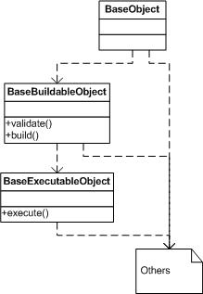

6.5.2 Configuration Loaders

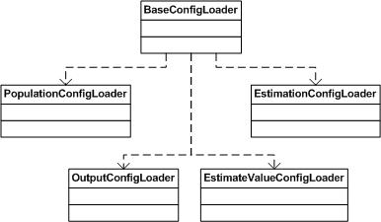

6.5.3 Directed Processes

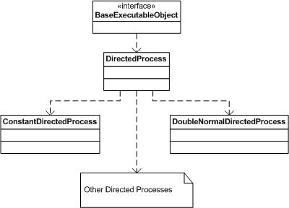

6.5.4 Estimates

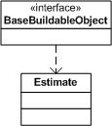

6.5.5 Layers

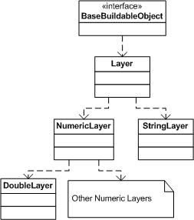

6.5.6 Minimizers

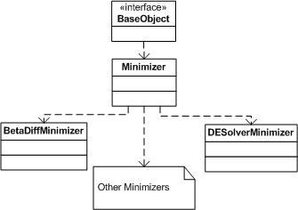

6.5.7 Observations

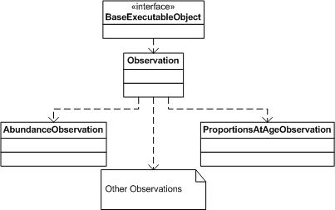

6.5.8 Print States

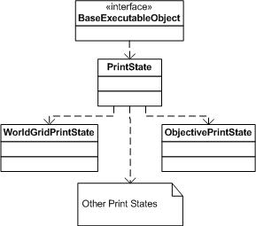

6.5.9 Priors

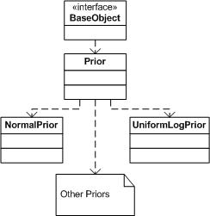

6.5.10 Processes

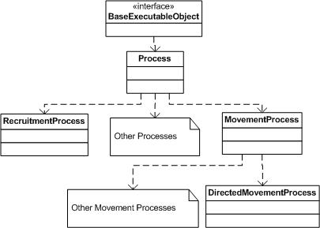

6.5.11 Selectivities

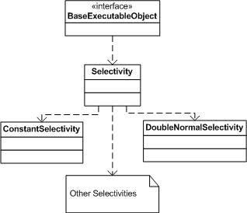

7.0 The Modelling Process

The modelling process is quite difficult to understand, but essentially the applications job is to mimic nature. The parameters of nature come from the configuration file. The application has to build a suitable environment that can model based on the configuration files requests.

Modelling consists of 2 main phases. The initialisation phase, and the modelling phase. Both are defined in similar fashions in the configuration files.

7.1 Initialisation Phase

This phase is run before the modelling phase; and is a kind of burn-in. The world will always start blank (everything empty) and the initialisation phase’s job is to bring the world upto something that represents the current state. The initialisation will typically be a >100yr system.

7.2 Modelling Phase

Once we have completed the initialisation phase, we start the modelling phase. This phase is the real grunt of the system. This is usually setup to run <20yrs worth of processes, but includes observations and print states (print outs).

8.0 The Print States

Like all good applications, it’s important to be able to get information out of the system. SPM uses what are called “print states” to achieve this.
There are 2 ways a print state can be executed.
- On a specific year, at the end of a specific time step
- At the end of a specific phase. (e.g Initialisation, modelling, final etc)

Current print states:
Name | Execution Phase | Description
Initial | Initial | The World after initialisation
Final | Final | The World after modelling
Current | Year/Step | The world at Year/TimeStep
Objective | Final | Print out of Objective Function
Estimate | Final | Print out ordered list of Estimables
Estimate Value | Final | CSV of Estimate Values for input with --values

9.0 Estimable Values

The minimisers have to interface to our model in order to change

When using a function minimiser some variable values will need to be changed of the minimiser in its attempt to find a best fit situation. Giving the variables to the minimiser is done as an array of initial values.

To hook this array into our model we use ‘estimates’. An estimate is a class that attaches itself to a value in another class. The EstimateManager is then hooked into by the Minimiser interface to build the array and modify the values.

The estimable values to be used will be defined in the configuration files.

10.0 Configuration Files

The configuration is broken up into 4 files.
File | Summary
Population.spm | Settings for the world, processes, layers
Estimation.spm | Settings for estimates, profiles, priors, observations
Output.spm | Settings for print states
Values.spm | Settings for estimate value inputs.  This runs the model with a pre-defined set of estimate values. Multiple lines will cause multiple runs. These files are generated by using the estimate_value print state.

The configuration files are laid out in section. Each section has it’s own parameters following.

e.g
@initialisation
initialisation_phases Phase1 Phase2 Phase3
run_years 14
start_year 1994
projection_years 100

The section is “initialisation” and the parameters are listed below it.

Single line comments begin with # and can be placed anywhere in the line. From the # onwards is considered a comment and ignored by the parser.

Multi-line comments are enclosed in { and }.

11.0 Estimate Value Input & Output

The model is capable spitting out the values of estimates after each run/minimisation. This is useful when profiling to get the values of all of the estimates after each profile iteration has converged.
They are loaded into a CSV file by the estimate value print state. By using the –values command line parameter SPM will look for values.spm that matches the estimate value format. It will load each line, and do a run for that line with those values. By loading in 100 lines you can get it to run 100x (on whatever run mode you decide).

This is also used for cross-application compatibility with CASAL etc.

12.0 Minimisation

Minimisation is the estimation run mode for SPM. Minimisation is the act of minimising the score of an object function to find the best fit of our model against a set of known observations.

The minimiser will send back the estimable array with new values until it think it has found the lowest possible score.

13.0 Profiling

When we run a minimisation we are allowing the minimiser to modify all of the estimate values as it decide. With a profile we will run multiple minimisations, but on each one we will fix the value of 1 estimate to a value we choose. This allows us to profile the effects each estimate has on the likelihood score.

14.0 MCMC

Markov Chain Monte Carlo. The MCMC will generate random estimate values for the model to run and check the likelihood score. If that score falls within a certain threshold that will be accepted as the new start point and new estimates will be generated.

This is typically run with a return accept rate of about 1million times. We are still working on methods to speed up the process so we can run a real one of these without having to retire before it’s complete.

15.0 Parameter Parser

The parameter parser is responsible for parsing the parameters coming in from the configuration file and providing a pointer to the variable in question.

e.g. population_process[Recruitment1].proportion

SPM currently supports:
- population_process
- directed_process
- selectivity
- q (catchability)

To ensure a variable can be parsed (and subsequently estimated) we need to register them within their corresponding class. In the constructor of any class that will have estimates we need to use the registerEstimable() function. This 1 function will ensure it becomes instantly accessible from the configuration file. No other code is required.

16.0 Macros (for numeric comparison)

Unfortunately, computers are crap at comparing decimal point numbers (float/double). Even 2 numbers created the same will differ in actual stored value. So using the standard == to compare them isn’t practical. Instead we have some macros we use.

#define ZERO 1e-10
#define SMALL 1e-4
#define DELTA 1e-10
#define isZero(A) ( (A < ZERO) && (A > -ZERO) )
#define isSmall(A) ( (A < SMALL) && (A > -SMALL) )
#define isSame(A, B) ( ((A-B) < ZERO) && ((A-B) > -ZERO) )
#define isSimilar(A, B) ( ((A-B) < SMALL) && ((A-B) > -SMALL) )
#define isBetween(A, B, C) ( ((A-B) > -ZERO) && ((A-C) < ZERO) )

Then in the code we can is if (isSame(double1, double2)) { } to compare doubles/floats. Along with the other functions which give us some other functionality when using inaccurate numbers.

17.0 Unit Testing

Unit testing is code that is written to test the code.

If we had a function for some banking software called “deposit”. When testing this we’d write at-least 2 Unit Tests.

- Test that we can deposit money into the account, and the balance increases
- Try and deposit a negative amount. The application should handle this with an error etc.

In SPM we use the Boost::UnitTest framework. It’s ideal because it’s part of the already used Boost library and is multi-platform.

The Unit Tests are stored in “Src/UnitTesting/” and are also setup in an OO Fashion.

e.g.
Running 103 test cases...

*** No errors detected

We are not aiming for 100% coverage with the tests; we only want to have a sufficient amount of coverage of the main functionality (e.g Layers, Selectivities, Processes). We don’t want any tests for the Managers etc.

18.0 Translations and Configuration Files

This project has highlighted the need for a standard configuration file syntax among the various modelling tools developed by NIWA. As part of the solution to this I have implemented a “Translation” system into SPM.

The translation systems primary functionality is to allow SPM to be translated in the other languages with little effort. All of the text strings are stored in a single header file and implemented in the application through a set of defines. The language include file used is based on a compiler flag.

This has also been quite useful as a way to collate all of the input commands from the configuration files and change some of them to be more consistent. The result was potential to translate SPM as well as making all of the inputs/outputs more consistent.

Note: I have templates some of the errors through the use of parent functions (e.g errorMissing() etc). I didn’t implement all of them like this as I realise that some languages do not have the same sentence structure as English.

